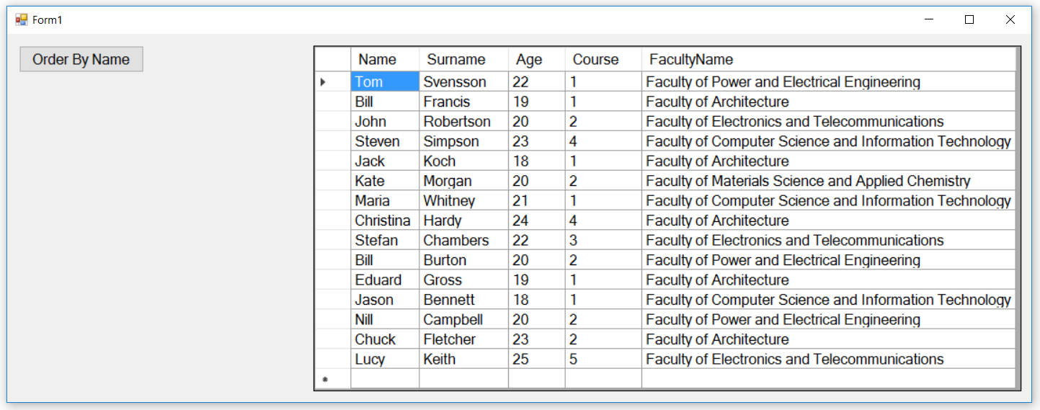

6

2

5

2

4

2

3

2

2

2

1

2

1. Select only records, where Name contains “c” and “j”.
2. Select only records, where Name and Surname contain “i” or “e”, order result by Surname DESC, then by Name DESC.
3. Select only records, where age is between 20 and 23.
4. Select only records, where two same letters exist within Name, Surname and FacultyName and order result by Name ASC.
5. Select only records, where Surname length equals to or is bigger than Name length.
6. Select only records, where Age+Course value is less than FacultyName text length.